Personal Position Statement on Drinking Alcohol
Ray L. Winstead
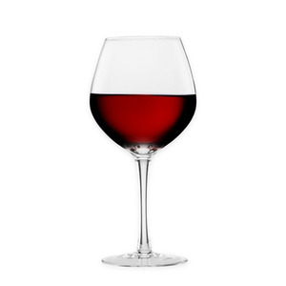
I think drinking alcohol for most people is not a good decision.*
1) News article about recent research conclusions on drinking alcohol:
“No, moderate drinking isn’t good for your health” March 31, 2023
https://www.washingtonpost.com/wellness/2023/03/31/moderate-drinking-alcohol-wine-risks/
"Drinking moderate amounts of alcohol every day does not — as once thought — protect against death from heart disease, nor does it contribute to a longer life, according to a sweeping new analysis of alcohol research."
"The review, which examined existing research on the health and drinking habits of nearly 5 million people, is one of the largest studies to debunk the widely held belief that moderate drinking of wine or other alcoholic beverages is good for you."
“This study punctures the hope of many that moderate alcohol use is healthy.”
Original Research: "Association Between Daily Alcohol Intake and Risk of All-Cause MortalityA Systematic Review and Meta-analyses" March 31, 2023
https://jamanetwork.com/journals/jamanetworkopen/fullarticle/2802963?utm_source=For_The_Media&utm_medium=referral&utm_campaign=ftm_links&utm_term=033123
2)
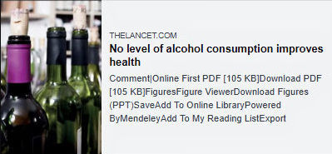
Image 1: “No level of alcohol consumption improves health.” “The conclusions of the study are clear and unambiguous: alcohol is a colossal global health issue and small reductions in health-related harms at low levels of alcohol intake are outweighed by the increased risk of other health-related harms, including cancer.” “There is no safe level of alcohol consumption.” Wikipedia: The Lancet is a weekly peer-reviewed general medical journal. It is among the world’s oldest, most prestigious, and best known general medical journals.” Online, the image links to the article. https://www.thelancet.com/journals/lancet/article/PIIS0140-6736(18)31571-X/fulltext
3)
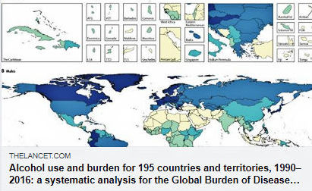
Image 2: “Alcohol use is a leading risk factor for global disease burden and causes substantial health loss. We found that the risk of all-cause mortality, and of cancers specifically, rises with increasing levels of consumption, and the level of consumption that minimises health loss is zero.” Wikipedia: The Lancet is a weekly peer-reviewed general medical journal. It is among the world’s oldest, most prestigious, and best known general medical journals.” Online, the image links to the article. https://www.thelancet.com/journals/lancet/article/PIIS0140-6736(18)31310-2/fulltext
An early study did show a possible health benefit to drinking wine, and this very preliminary result from a small study saturated the popular news media. This study, of course, did stimulate other research studies. However, the follow-up studies showed that the positive results observed were almost exclusively due to the health-protecting chemical antioxidants resveratrol and flavonoids present in the wine – not the alcohol. These antioxidants were originally from the skin and other parts of the grape.
Further studies showed that you would get the same positive health benefits by drinking purple grape juice - without the undeniably adverse effects of drinking alcohol.
Check it out for yourself. (WebMD: "These dietary antioxidants can prevent the development of cardiovascular disease, diabetes, cancer, and cognitive diseases like Alzheimer's and dementia." Other sources: These chemicals have beneficial health benefits, such as being antioxidant, antitumor, anti-inflammatory and anti-aging.)
Studies have also shown that in some situations, a very, very small part of a positive effect of the wine is unknown and could be due to the alcohol. As a biostatistician, especially check the “Strength of Association” measures that show the RELATIVE importance of the independent variables, e.g., alcohol and antioxidants, as they affect the health effects. A “statistically significant” result could be very, very small (but real) - but is not necessarily an “important” (proportionally large) effect on the dependent variable in that natural system! In particular, the effect of the alcohol itself is so small on positive health indexes, however, relative to the other variables, e.g., the antioxidants, as to be practically worthless – while the negative effects of alcohol are overwhelming. So, drinking a little wine may be helpful with a little health benefit to a few people in particular situations. The probability, however, is that you, although possible, are not one of them – in spite of what you may think. You may think there are some short-term “benefits,” but a health benefit is probably not one of them.

"For young adults ages 15–39, there are no health benefits to drinking alcohol, only health risks," according to a scientific article published in The Lancet. (Wikipedia: The Lancet is a weekly peer-reviewed general medical journal. It is among the world's oldest, most prestigious, and best known general medical journals.") LINK TO ARTICLE https://www.healthdata.org/news-release/lancet-alcohol-consumption-carries-significant-health-risks-and-no-benefits-young

4) Tidbits

A tidbit: When brain cells die, they don’t grow back or get replaced. EACH drink of alcohol kills brain cells. (Also see the YouTube video on other more short-term negative effects of alcohol on your brain. https://www.youtube.com/watch?v=CJynHWYo7D8) The death of these brain cells may not be immediately obvious, since it is a cumulative, adverse effect, so it is more likely to be noticed as a person who drinks gets older. (Sublevel tidbit: some brain cells in birds DO grow back, and research is being done to try to discover the mechanisms of that process in birds to try to develop practical processes of how to stimulate human brain cells to reproduce – to treat mental decline caused by other reasons.)
A tidbit: Statistics show that people who drink alcohol have more car accidents – even though alcohol was not directly involved with an accident. One conclusion is that the decision to drink alcohol in many people is an index of their lack of good judgment – which, in turn, causes them to have more car accidents – even when alcohol is not involved.
A tidbit: The alcohol you like to drink is yeast pee! The alcohol you drink is a waste byproduct of the energy conversion process with fermentation in yeast cells. The image below shows a yeast cell budding off an "offspring," as well as the cells relieving themselves of their waste alcohol. The image is also a link to my webpage about fermentation. Link https://raywinstead.com/fermentation.shtm
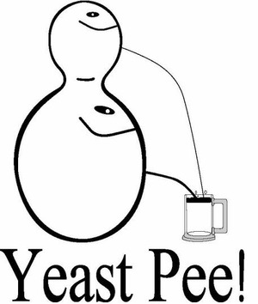
* Disclaimer and acknowledgement: Of course, research is still being done with controversial results on the relative causes of a person “simply” deciding to drink alcohol versus whether there is an underlying genetic predisposition to abuse alcohol. The truth for society as a whole is probably a combination of the two – with important differences in these factors among individuals. It is well known that more drinking both for society and individuals will cause the situation to decline and continue to get worse. Regardless of the cause for an individual, I hope those people who need help will be able to use the resources available to them to get that help.

