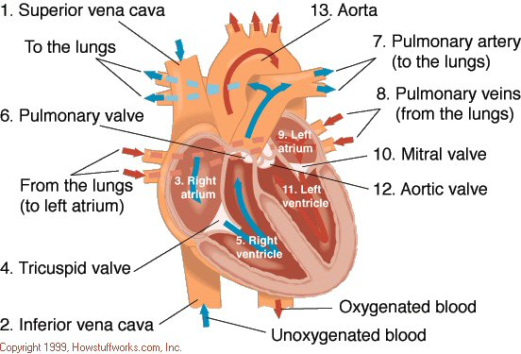

Pathway of blood through the heart
Right Atrium
Tricuspid Valve
Right Ventricle
Pulmonary Valve
Pulmonary Artery
Lungs
Pulmonary Vein
Left Atrium
Bicuspid Valve = Mitral Valve
Left Ventricle
Aortic Valve
Aortic Artery

